Lionel 2046 Motor Replacement
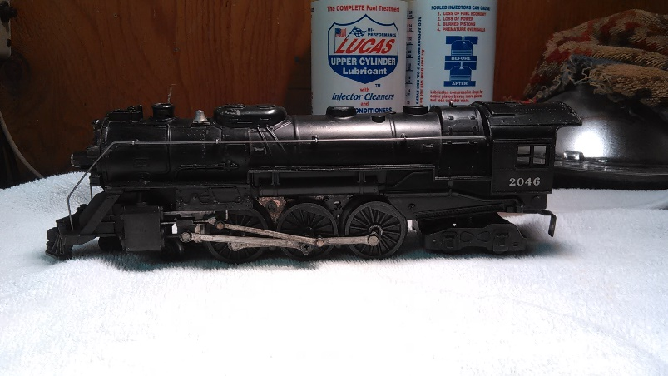
I purchased the engine originally on Ebay for about $100, ran great for about 10 years. But began having trouble with the gears jamming, upon investigation found the front axle’s bushings were badly worn, this allowed excessive movement of the axle and gears meshing (pic #1). Found a new motor from a guy who purchased stock from Madison Hardware in NYC for $99.00 (pic #2). Received the motor and began planning the motor swap. Evaluated the new motor for dimensioning, wiring, attachment holes, size, wheels, main cranks L&R and operation. Will take about 3-4 hours to complete and test. Prepare the area, flat surface, bright spot light, white towel (in case you drop something), shrink wrap, hand tools (pic#3). Remove rear wheels and shell from engine. Dis-assembly of old motor (keep all parts separated in batches Pic#4), remove; 1st smoke unit & bulb, cut wire far away from unit and remove piston/spring, 2nd front wheels, 3rd cow catcher, 4th L & R driving gear, be careful with the aluminum pins that attach the cranks, 5th front aluminum brace, this has two 5/32” pins that attach to the motor(pic#5), this will require a punch, hammer and small diameter deep socket. Start with pin outside and then inside closest to motor. With all the accessories removed, put motor on its side pin heads facing down (use a book about 2-3” high to support motor), take socket put under pin head and hit punch into shaft of pin(pic#6), will come loose, careful not to damage aluminum brace. You may need to use needle nose pliers or needle nose vise grips to remove pins. Next clean up all parts that you removed with paint thinner and scotch brite, except shell (keep all parts in separated in batches). Do not re-bend any parts that may look bent, there is a reason for this.
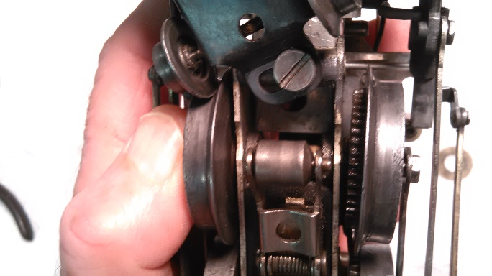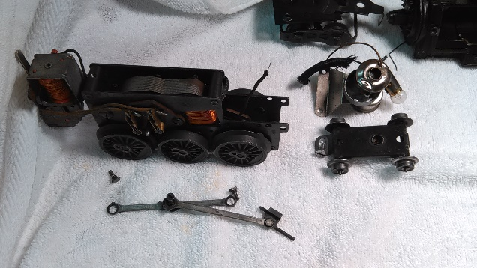
Pic#1 Pic#2
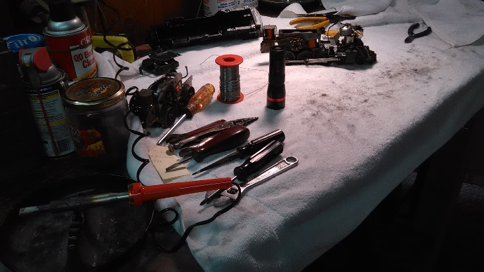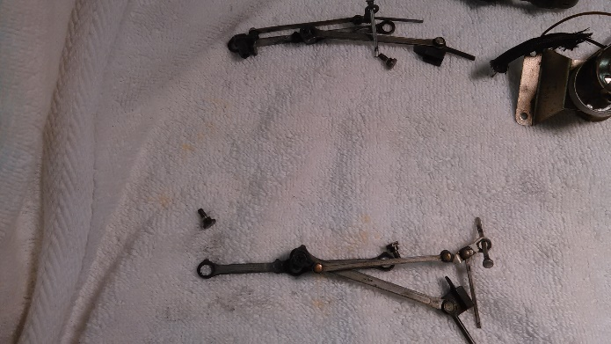
Pic#3 Pic#4
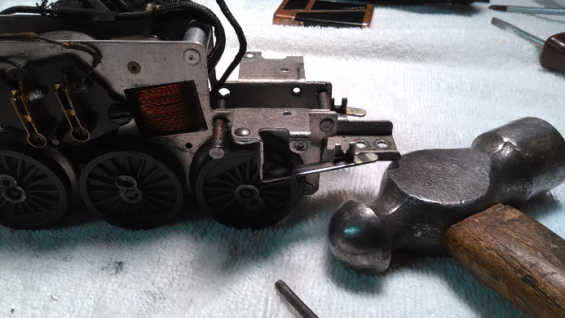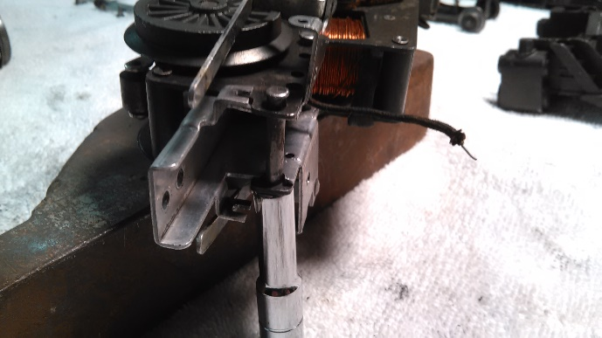
Pic#5 Pic#6
Now compare the old motor with the new motor, pay attention to the 5/32” pin holes location (pic#7). Ready to re-assemble, 1st front aluminum brace, this has two 5/32” pins that attach to the motor, this will require a punch, hammer and small diameter deep socket. Start with pin inside closest to the motor and then outside. Put motor on its side pin heads facing up (use a book about 2-3” high to support motor), take socket put under pin and hit punch into shaft of pin head, seat as best as possible(pic#6), 2nd cow catcher attach two screws, check alignment(pic#8), 3rd L & R driving gear, center lobes fit precisely into the center wheel(pic#9), you’ll see that these lobes are offset by about 180° between L and R wheels, if not done properly it will jam. Feed the rods/pistons into the steam chest and both slides as well, be careful with the aluminum pins that attach the cranks they can break easily. Looks nice as you have cleaned up the parts. 4th install front wheels (pic#10), 5th smoke unit & bulb, the holes may have moved wider L to R on brace during assembly, may need to elong gate the holes in the smoke unit so that they are closer together (dremmel tool), screw smoke and light fixture with piston/spring in place into brace(pic#11). Now run engine back and forth on the towel to test for any jamming, roughness or excessive noise and if all is okay. Heat solder iron up, I like the Weller 80 watt and heat sinks on the wires. Strip wire from engine power pickup, light bulb and smoke unit. Cut a piece of shrink tubing long and wide enough to fit over wire junction. Put shrink tubing on wires and below the heat sink (or it will shrink on you). Solder all three wires and shrink the tubing down to a tight fit (pic#12). Next put PTFE grease on all gears (white dots) and 3 in 1 oil on all axles and linkages (pic#13&14), a few drops of smoke oil in the stack and ready to test the surgery. Wait to assemble rear wheels and shell until fully tested for operation and heat. Run on a track at slow speed first with a bright flash light (to see), run forward, neutral, reverse. Increase speed as confidence builds. Check the linkages, light, smoke unit, sparks from power pickups, e-unit and is anything hot to the touch? Passed the test, assemble rear wheels, shell and attach the tender, let go hi balling.

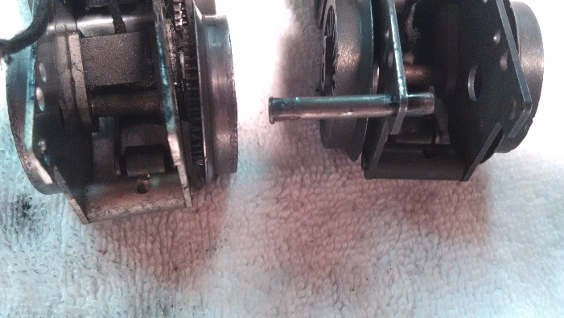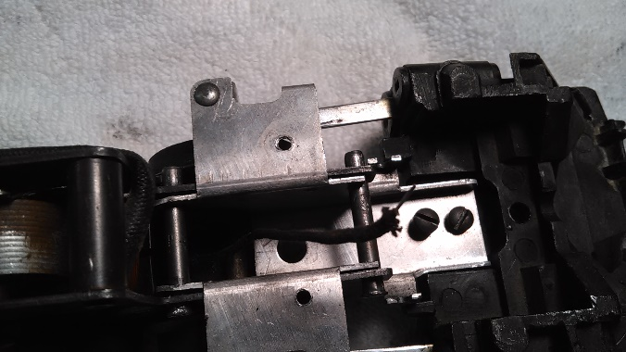
Pic#7 Pic#8
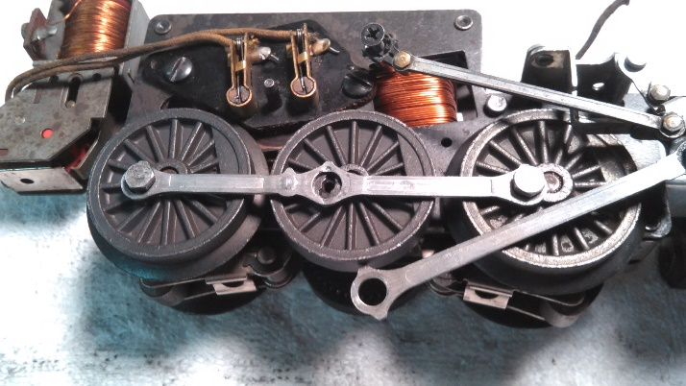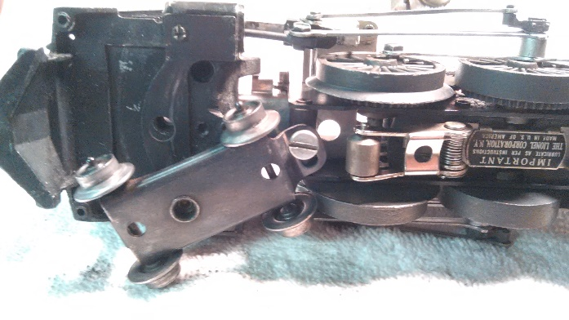
Pic#9 Pic#10
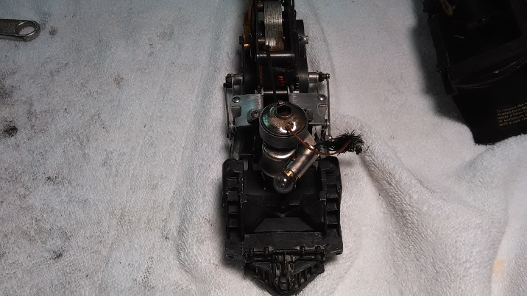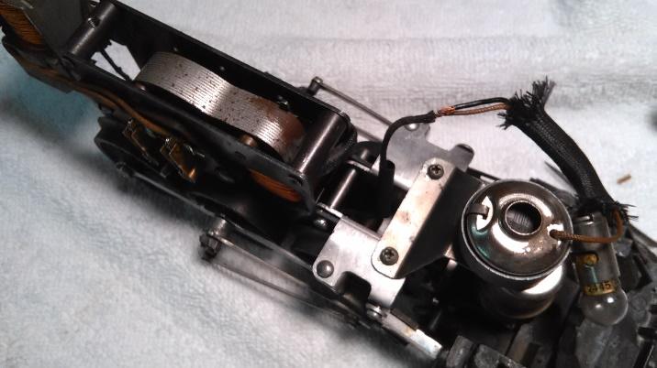
Pic#11 Pic#12
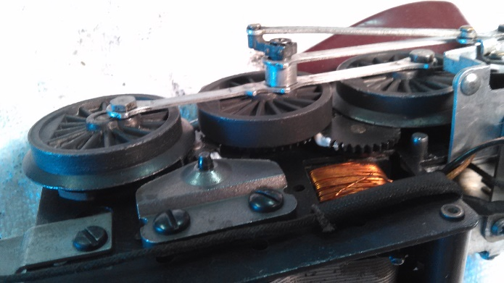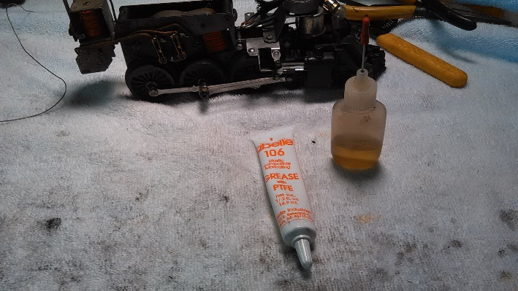
Pic#13 Pic#14
The problem I had was the aluminum brace looked bent so I straightened it out, this caused it not to fit when I re-assembled the unit. I had tried to re-bend it but it didn’t work out. That caused me to use a dremmel tool on the smoke unit holes. I had originally considered replacing the brass axle bushings on the frame but it was more cost effective to just replace the entire motor. I also found that True Value has a lot of hardware for these 1950’s engines if you need it. Lastly remember to keep you wheels and power pickups clean for better performance of the engine. Look for my Lionel 2046 at the next module train show, it runs spectacular, with a new motor.
Tim #17784

