Lionel 4410 Daylight Southern Pacific aka the Phoenix
I bought a Daylight S.P. at the convention, it looked good physically, mechanically and was a decent price. When I got home I tested it and growled a little but it didn’t smoke, a steam engine that doesn’t smoke? I thought I had a lemon. So I did some research on you tube and couldn’t find any of these 4410 that smoke from the 1991 version or newer. This began setting the wheels in motion, I had a brand new MTH AA-0000014 smoke unit cost $50.00 from MTH and thought will it work and fit in the 4410 front nose. Granted it would not be original, but it would really smoke like a steam engine needs to be. First I evaluated the system, it had two ¼” tubes coming from the top of the smoke unit down to the steam chest, one 20 watt resistor in the smoke unit (AC power), Lionel piston to pump smoke, a 10 watt bulb (DC power), the entire bulb and smoke unit was a tan plastic type material and all was mounted on brackets in the nose of the engine. Circuits are DC comes from a full wave rectifier (converts AC to DC) this is constant voltage power to the bulb and AC comes from the track power via a junction to power the smoke unit. The initial design was to reuse the DC bulb/part of the bracket, fabricate a “Z” bracket to mount the MTH smoke unit and bulb in the nose of the engine. So I made measurements of the original Lionel unit L x W x H, tested the AC to DC power supply, tested the AC feed to the smoke unit, also oiled the drivers and put lube into the worm gear box (it was dry, probably the growl), cleaned the brushes and armature plate (sand paper/paint thinner), cleaned the electrode (sand paper) and wheels (paint thinner/q tip) and then removed the old Lionel smoke unit and bulb. I had previously tested the MTH unit and it worked outstanding, smoked like a demon! I have a small Lionel transformer for testing engines by using jumper wire and alligator clips at each end. Put one clip on the frame and one clip on the electrode, works pretty good for testing.

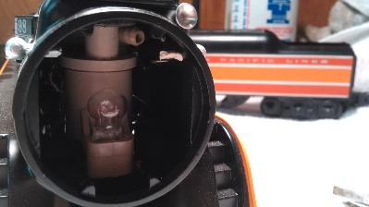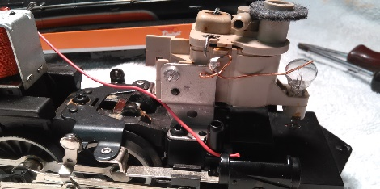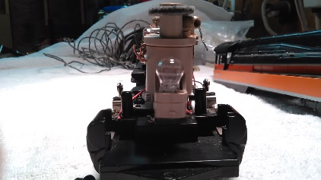
This is the original configuration.

Now the fun starts, with my dremmel tool I fabricated the “Z” bracket from aluminum based on the measurements, taped the smoke unit to the “Z” bracket and taped the “Z” bracket to the engine frame, installed the engine cabinet onto the frame and checked the smoke unit alignment thru the top, position to the front for the bulb and side to side for the possibility of short circuits on the frame, it needed a slight push to the left for a perfect alignment. I then marked/measured the “Z” bracket, smoke unit and frame. Drilled a #38 holes into the “Z” bracket and attached the smoke unit (had 4/40 holes already). Next drilled holes into the “Z” bracket on the frame side, put tape as well, did a final alignment check and back drilled the #38 holes through the “Z” bracket into the frame and tapped the holes for 4/40 threads into the frame. Installed the 4/40 screws and rechecked the overall alignment, perfecto. Removed the smoke unit from “Z” bracket to align the bulb bracket. Now with my dremmel tool, need to cut the existing bulb bracket to fit , fabricate a .500” L by .250” W aluminum extension from the center of the “Z” bracket to the bottom of the modified tan plastic bulb bracket and de-solder the existing wires. Drilled two #38 holes on each end thru the 500” L by .250” W extension. Back drilled the hole thru the bulb bracket and tapped the hole 4/40 threads. Mounted the bulb with a 4/40 screw and extension bracket onto the “Z” bracket using tape, set it to the previous measurements, and checked the bulb bracket with the engine cabinet/shell and front cover on, needed to move it right a little (best to use tape at first). Removed cabinet/shell and cover, marked the extension bracket onto the “Z” bracket and back drilled the hole. Next dis-assembled the parts and deburred, rounded all edges. Re-assembled bulb extension to “Z” bracket, installed smoke unit on top of “Z” bracket and installed “Z” bracket assembly onto the frame with star washers to keep all the screws from coming loose.
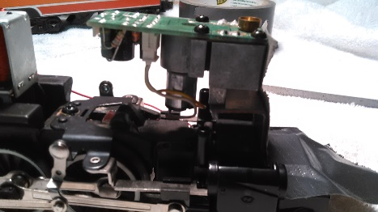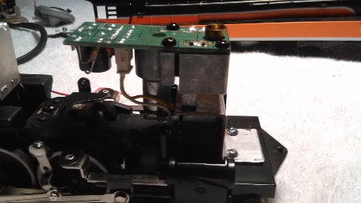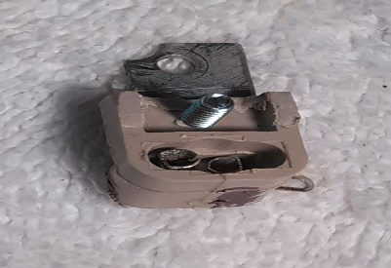
At first tape the unit in “Z” bracket bolted in Bulb bracket ready to installed
Next is to wire the smoke unit and bulb up to their AC or DC power sources. Heat up the 80 watt soldering iron, shrink tubing, strip wires and plan wire lengths/routing, ground using a spade connector to the frame, red wire is hot and black is ground. Began soldering up the wires, making sure to install shrink tubing (don’t use tape it falls off allowing bare wires) prior to soldering, soldered up black wire ground from bulb and smoke unit circuit board pin #2 to grounding spade, soldering up red wire DC line from power source to bulb, soldered red wire AC from junction to smoke unit circuit board pin #1. Lastly installed grounding spade connector with a star washer to make for a great ground on the frame. For a component to work you must have a good power source and your ground must be as good.

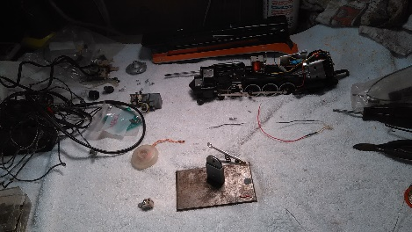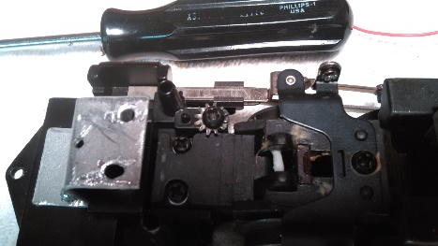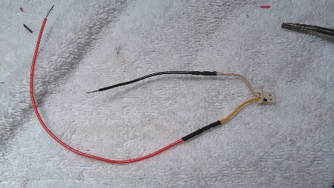
Work area “Z” bracket completely drilled out AC power feed for the smoke unit

Now is the moment of truth, I double checked all wiring connections, hardware, bolts, added smoke fluid to the unit and the bulb. I tested the engine without the shell or cabinet on just in case there was a problem. Wow it smokes like a demon or a MTH steam engine should and the bulb works as well. Installed the cabinet/shell with a large “O” ring/felt seal around the smoke exhaust and tested it, great alignment of the smoke unit to the top hole and the bulb to the external graphics overall great alignment. It is also easy to add smoke fluid. Engine runs consistently well!

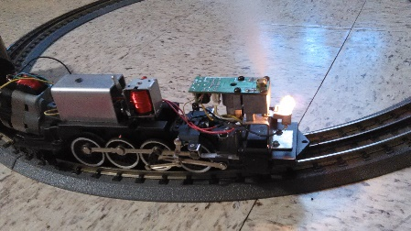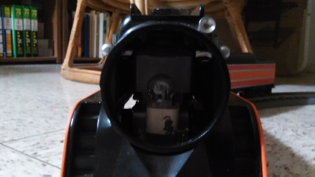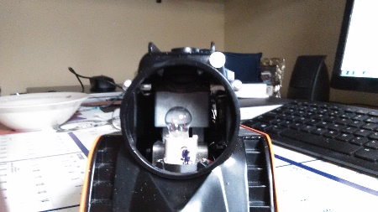
The new configuration A comparison of both units before and after.
I took about 2 months from design to project completion. Patience and planning are important, but always take pictures of projects as they progress. Make a decision at the start, if you ever plan to go back to the original configuration, then you must not destroy the parts, save them and with the pictures you can recreate what you have changed. We have a saying in my business when you reach what appears to be show stopper take a break and come back refreshed. It’s like sitting to close to the fire you get your feet burned, you need to take a break get refreshed. This type of work on trains is sometimes called kit bashing, but I call it having fun and being an operator.
End result I took a great looking, 1991 Daylight S.P. vintage engine by Lionel and brought it back to life better than it ever was, even when it was brand new. It smokes as a steam engine should, lights up, great whistle/bell, oiled/lubed and cleaned up. Look for the Lionel 4410 Daylight Southern Pacific at the next TTOSNMD module event.
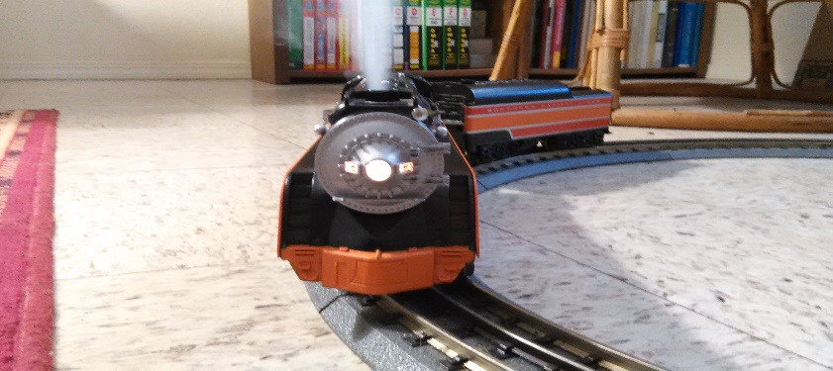
Now that’s a steam engine!

